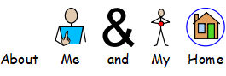

|  |  |
| --- | --- |
|  | Over the next month, you have to stay at home. This is so people don’t get sick which is very important. |
|  | While we might miss seeing our friends and staff at Share … |
|  | There are still lots of things you can do at home! This will help you learn and keep your brain healthy. |



  
  
  
  
  
  

