|  |  |
| --- | --- |
| **Name:** |  |
| **Date:** |  |

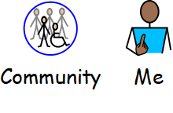

**My Community and Me – Hobbies Survey**

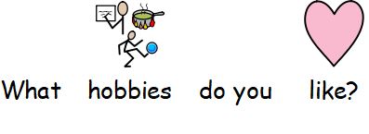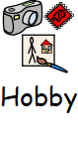

**What hobbies do you like?**

|  |  |
| --- | --- |
| **Hobby** | **Who likes this?** |
| Word search |  |
| Colouring |  |
| Knitting |  |
| Creative writing |  |
| Cooking |  |
| Hama beads |  |
| Photography    Do you have a mobile phone or tablet with a camera? |  |
| Gardening |  |

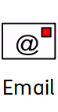**Email a copy of your completed sheet to:** [Jennyb@sharecommunity.org.uk](mailto:Jennyb@sharecommunity.org.uk)