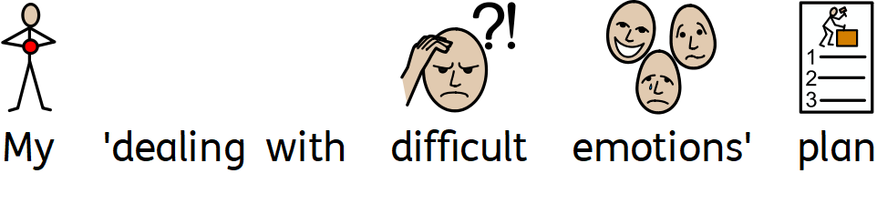
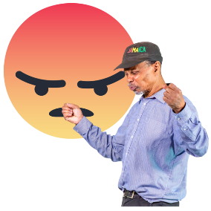 | When I feel a difficult emotion I will do these things:
1
2
3

