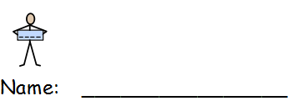My skills and qualities

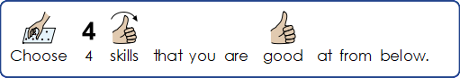

|  |  |  |
| --- | --- | --- |
| CV Write 2Hardworking | Friends7 2Friendly | Honest  [Image result for truth](https://www.google.co.uk/url?sa=i&url=https://www.e-ir.info/2018/10/22/defining-post-truth-structures-agents-and-styles/&psig=AOvVaw0VYJ4kgWJHxTcIDquREvK1&ust=1583927478616000&source=images&cd=vfe&ved=0CAIQjRxqFwoTCPDsuOjrj-gCFQAAAAAdAAAAABAE) |
| Good at teamwork  Plan Together | Organised  Files1 | Always on time  [Image result for on time](https://www.google.co.uk/url?sa=i&url=https://fireuptoday.com/strategies-to-help-you-get-to-work-on-time/&psig=AOvVaw2n5EGkncQu3cLvCIvRXQ7o&ust=1583927250044000&source=images&cd=vfe&ved=0CAIQjRxqFwoTCNj2tPrqj-gCFQAAAAAdAAAAABAK) |
| Good at Maths  Calculator | Good at art  Art | Good at listening  Listen |
| Good with Money  Money - British | Good at writing  Puzzle | Help 3Helpful |

1.

2.

3.

4.